**Game Design Document –**

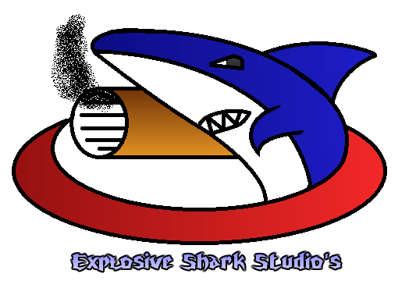

Sebastiaan van Dijk

Nick Kortleve

Jan Willem Jozic

Lionel Mithoe

Bart Dikmans

Contents

Summary 3

High level concept 3

Design goal 3

Visuals 3

Audio 3

Screen Passage 4

Formal Elements 4

Players 4

Objectives 4

Procedures 4

Game 5

Rules 5

Resources 6

Conflict 6

Boundaries 6

Outcome 6

Dramatic Elements 7

Challenge 7

Play 7

Premise 7

Target Audience 7

Visueel 9

Audio 9

Robuust en gevariëerd 10

Sound priorities / HDR-audio 10

Audio states / sound moods 10

# Summary

## High level concept

* Player vs Player
* Racing game, players have to reach the checkpoints as fast as they can in a giant world where they vary between planet-surfaces and space landscapes like asteroid fields.
* Any age

## Design goal

* Race game with a lot of freedom, Really compact and reaction-driven across the planet surfaces and open and free in space, in space there will be ways to compensate for steering away from the race, like wormholes or boost-recharging nebulas
* Big fast-paced race tracks
* Fighting with other players, by shooting them from behind, knocking them off-course

## Visuals

## http://1.bp.blogspot.com/-A7l3fg5O9Hg/VNiB906-HvI/AAAAAAAAC-8/2FhPZWq77cY/s1600/freelancer2.jpghttp://www.mobygames.com/images/shots/l/38667-freelancer-windows-screenshot-eventful-campaign-2-a-space-race.jpg

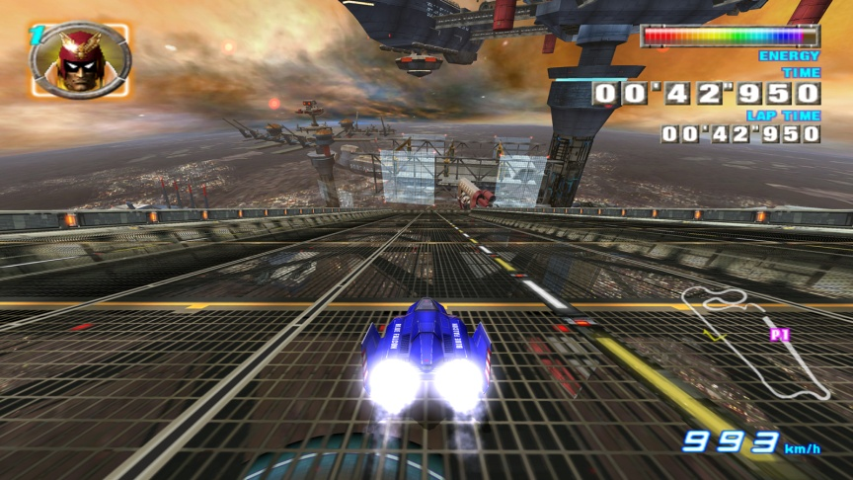

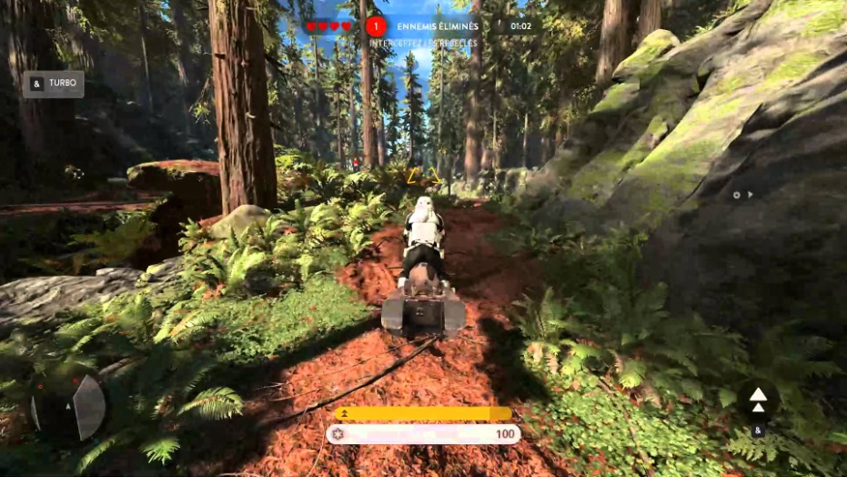

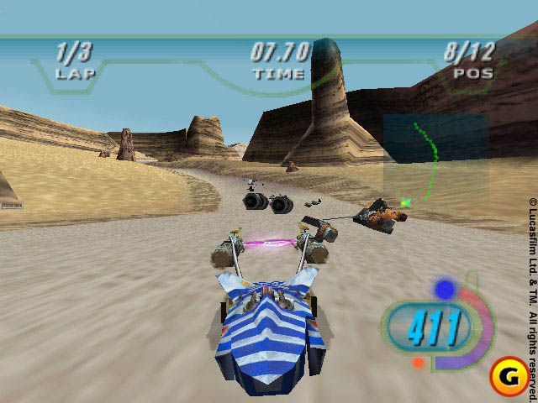

## Audio

Menu muziek: Sport-game menu muziek

https://www.youtube.com/watch?v=_K8UdnLNSKQ

In the race muziek: energetic and fash for a race vibe

https://www.youtube.com/watch?v=xvwgkhjVM7w

https://youtu.be/N0NlVypWHTQ

Ship sounds: Lasers being fired, Engine exhaust, Crash sounds, scraping sounds, shield sounds.

# 

# Screen Passage

**Dafuq is a screen passage?**

# Formal Elements

## Players

* **How many players can play the game**
* 1-4
* **Is there player interaction**
  + Yes, the players race against eachother and try to defeat eachother during the race. By outracing them or using tools to disrupt other players performance (powerups, weapons)
* **Can I see what other players have accomplished during the game?**
* Yes, the players will be able to view the position of themselves and the other players during the race. They will also see the finish times at the end of the race.

There is no permanent death, if a player crashes they respawn a few seconds later.

## Objectives

* **What is the goal of the game**

The goal of the game is to win the race by defeating your opponents and finishing first

* **How does the player know what the goal is**

There will be indications like a waypointer

A skippable quick run through the map at the start of the level

There will be audio and visual feedback.

* **How can the player reach their goal?**

By completing the race track and defeating the other racers while avoiding their attempts to disrupt the player

## Procedures

Controls

|  |  |  |  |
| --- | --- | --- | --- |
| Knop | Actie | | |
| Left Mouse Button |  | Fire basic bullet |  |
| E | Activate Powerup |
| Escape | Menu |
| Up / W | Accelerate |
| Mouse | Steer |
| Left / A | Tilt Left |
| Right / D | Tilt Right |
| Shift | Boost Power |
| Space |  | Brake |  |

|  |  |  |  |
| --- | --- | --- | --- |
| **XBOX -Controller** |  | **Action** |  |
| B |  | Fire basic bullet |  |
| Left Trigger |  | Activate Powerup |  |
| Start button |  | Menu |  |
| Right Trigger |  | Accelerate |  |
| Left Thumbstick |  | Steer |  |
| Left Direction pad |  | Tilt Left |  |
| Right Direction pad |  | Tilt Right |  |
| Y |  | Boost Power |  |
| X |  | Brake |  |

## Game

* Race and outwit
* Try to finish first by:

Outmanouvering your opponents

Outsmarting them

Disrupting their flight

Outrun them

## Rules

Players can fly freely in all axis.

Players can interact physically with objects using their ship.

Players have to complete a race by reaching checkpoints.

First player wins the match

Players can interact with each other using their weapons, ships and power ups

Life is defined by an energy meter. Energy meter counts for both the health and boost power. A player can risk going faster at the cost of their health, or fly without boost and maintain their shields. Energy can also be used to fire lasers, Lasers won't do much damage but they knock players around slightly so they can get knocked into objects or get thrown off-course

If a player loses their shield (energy is 0) they can't use the boost and any impact from an outside source will cause the player to crash

Players who crash aren't dead and will respawn 4 seconds later back on the track closest to them.

Next page contains resources the players can use to help themselves.

## Resources

* Define the resources
  + What Resource?
  + What does it do?
  + Why this resource?
  + When can a player get this?

|  |  |  |  |  |
| --- | --- | --- | --- | --- |
| **Resource** | **Effect** | | **Waarom** | **Wanneer** |
| **Recharge fields** | **Areas that you can fly through to recharge your energy levels** | | **Standard way to maintain the energy levels by staying on a designated track** | **Several places across each map** |
| Distractron Mine | Sticks to a player that flies near it and causes a short direction change |  | Will be a bother to people to distract them a bit | When you're in front of people you won't have the luxury to fight backwards, this way you can! |
| Distractron Pack | A pack that will periodically cause random direction changes to really harass someone |  | Will be a temporary nuisance to people | When you're in front of people you won't have the luxury to fight backwards, this way you can! |
| Straight Torpedo | Fires a missile directly forward to knock a player aside with a punch, very fast |  | Will slow a player and cause them to get thrown around | When you're not in the lead |
| Torpedo Salvo | Fire up to three missiles directly forwards to knock a player aside with a punch, very fast |  | Will slow a player and cause them to get thrown around, but now you can chain it | When you're not in the lead |
| Seeker Missile | Fires a seeker missile directly to the first player in front of you to knock them aside with a punch, fast, but can be outran temporarily with a boost |  | Will slow a player and cause them to get thrown around, guaranteed | When you're not in the lead |

|  |  |  |  |  |
| --- | --- | --- | --- | --- |
| **Resource** | **Bonus** | | **Waarom** | **Wanneer** |
| Seeker Missile Salvo | Fires up to three seeker missiles directly to the first player in front of you to knock them aside with a punch, fast, but can be outran temporarily with a boost |  | Will slow a player and cause them to get thrown around, guaranteed, but now you can chain it | When you're not in the lead |
| Explosive Shark | This games equivalent to the Blue Turtle Shell, shoots ahead and will ram every player ahead of you, big time! |  | Will knock down everyone ahead of you | When you're in the last 3 spots |
| Small Energy Pack | Increases your energy level by 20% |  | Will recharge your shield/boost power | Anyone can get it |
| Medium Energy Pack | Increases your energy level by 50% |  | Will recharge your shield/boost power | Anyone can get it |
| Super Energy Pack | Increases your energy level to 100% and makes your energy unlimited for a few seconds |  | Will recharge your shield/boost power | The players in the last 3 positions can get this |
| Black Hole Shield | Turns you into a ball of death, gain invulnerability, speed and can crash players you fly into. lasts for a few seconds |  | You become untouchable for a little bit | Players in the last 5 positions can get this |
| Wormhole Generator | Will send the last player ahead by half the distance between the second to last player and the first player |  | Will jump you ahead in the race | The last player |
| Stealth Drone | A mine you drop behind you that will look like a power up but explodes on impact instead |  | Will distract gullible players | Anyone can get it |

## Conflict

* The position of the players on finishing the race determines the amount of points they get. First place gets most, last place gets least.
* Enemies will try to beat you to the finish, along with several obstacles

## Boundaries

* The player can't fire backwards.
* The player can't steer off the track or will be shot by referee ships.

## Outcome

* A highscore.
* The position of the players on finishing the race determines the amount of points they get. First place gets most, last place gets least.

# Dramatic Elements

## Challenge

* **What is the challenge?**
* Trying to win the race against multiple players while handling the multiple different strategies that can be used to play the game.
* **What is the buildup in the challenge?**
* The more the players play the game they better they will get. Therefore the challenge depends on the skill of the player and of his opponents. The better they are the rougher it will be to correctly handle all of the different options available to the players.

## Play

* It’s a race game where you compete with other players. Due to the inclusion of basic shooting mechanics, power ups and multiple ways to complete the track there are multiple different available strategies

## Premise

* You are part of a Space Race and you want to win. Enjoy.

This page doesn't wanna get removed. send help.